Practical results – Robert Millikan.

In an experiment performed in 1915 (and published in Physical Review,, vol VII, p. 362 (1916)), Robert Andrews Millikan set up a system in which he could measure the photoelectric effect accurately from freshly scraped surfaces of alkali metals. The glass vessel shown below was evacuated; one of the metal samples mounted on the wheel W at the centre was rotated to bring it next to the knife K, which scraped it clean; then the sample was rotated 180 degrees to face light shining through aperture O.
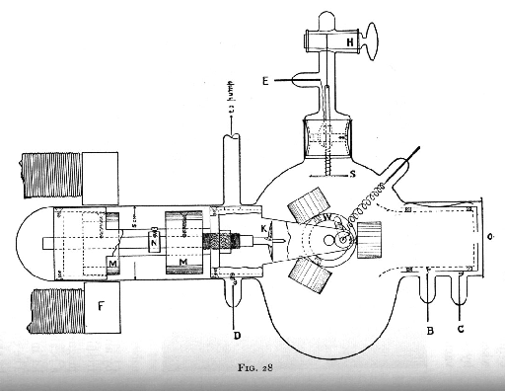

Millikan's data is shown below. He shone light of various frequencies (plotted on the horizontal axis; note the factor of 10 to the 13'th power!) on the metal plate, and determined the minimum voltage (plotted on the vertical axis) necessary to halt the induced current.

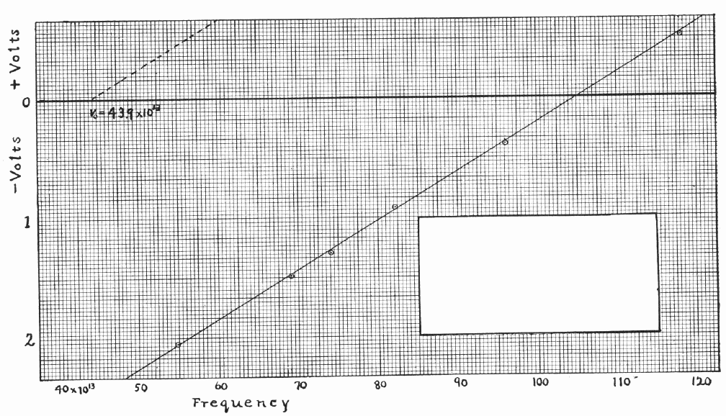

Does the stopping voltage increase linearly with frequency of the incident light?
What is the value of Planck's constant h based on this data?

Does the stopping voltage increase linearly with frequency of the incident light? What is the value of Planck's constant h based on this data?

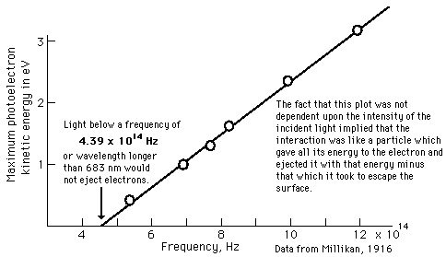

WEB LINKS.

Data + notes:
http://hyperphysics.phy-astr.gsu.edu/hbase/mod1.html#c5
http://www.saburchill.com/physics/chapters/0128.html
http://www.saburchill.com/physics/chapters/0129.html
http://www.saburchill.com/physics/chapters/0130.html
http://www.chembio.uoguelph.ca/educmat/chm386/rudiment/tourexp/photelec.htm
http://galileo.phys.virginia.edu/classes/252/photoelectric_effect.html

http://hyperphysics.phy-astr.gsu.edu/hbase/mod2.html#c3

Work function values;
http://hyperphysics.phy-astr.gsu.edu/hbase/tables/photoelec.html#c1

Practical experiment:
http://www.sciencejoywagon.com/physicszone/lesson/10modern/photoelc/
http://panda.unm.edu/Courses/Fields/Phys491/Notes/PhotoelectricEffect.pdf

Robert Millikan info + actual results:
http://focus.aps.org/story/v3/st23
http://spiff.rit.edu/classes/phys314/lectures/photoe/photoe.html
http://www.oufusion.org.uk/PhotoelectricEffect.htm

History and Oil drop Experiment
http://people.clarkson.edu/~ekatz/scientists/millikan.html

Look also at the Physics Lab simulation and take some results!

